Tim Driscoll

Lab 3 Pre-Lab

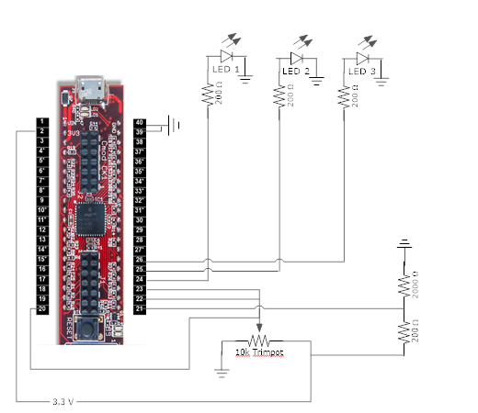September 18, 2019